
Purpose
This policy will define the:
- procedures to be followed if a child is ill, or is involved in a medical emergency or an incident at the service that results in injury or trauma
- responsibilities of staff, parents/guardians and the approved provider when a child is ill, or is involved in a medical emergency or an incident at the service that results in injury or trauma
- practices to be followed to reduce the risk of an incident occurring at the service.



Policy Statement

Values
Renown Kindergarten is committed to:
- providing a safe and healthy environment for all children, staff, volunteers, students and any other persons participating in or visiting the service
- responding to the needs of an injured, ill or traumatised child at the service
- preventing injuries and trauma
- preventing the spread of illness through simple hygiene practices, monitoring immunisation records and complying with recommended exclusion guidelines
- maintaining a duty of care to children and users of Renown Kindergarten

Scope
This policy applies to the approved provider, persons with management or control, nominated supervisor, persons in day-to-day charge, early childhood teachers, educators, staff, students, volunteers, parents/guardians, children and others attending the programs and activities of Renown Kindergarten, including during offsite excursions and activities.

Responsibilities | Approved provider and persons with management or control | Nominated supervisor and persons in day-to-day charge | Early childhood teacher, educators and all other staff | Parents/guardians | Contractors, volunteers and students
R indicates legislation requirement, and should not be deleted
- Ensuring the Incident, Injury, Trauma and Illness Policy and procedures are in place (Regulations 168) and available to all stakeholders (Regulations 171) | R | √
- Taking reasonable steps to ensure that nominated supervisors, early childhood teachers, educators, staff and volunteers follow the policy and procedures and are aware of their responsibilities (Regulations 170) | R | √
- Ensuring that the premises are kept clean and in good repair | R | R | √ |  | √
- Maintaining effective supervision (refer to Supervision of Children Policy) for all enrolled children in all aspects of the service’s program that is reflective of the children’s needs, abilities, age and circumstances | R | R | √
- Regularly checking equipment in both indoor and outdoor areas for hazards (refer to Attachment 1), and taking the appropriate action to ensure the safety of the children when a hazard is identified | R | R | √
- Being proactive, responsive and flexible in using professional judgments to prevent injury from occurring | R | R | √ |  | √
- Having ready access to an operating telephone or other similar means of communication to enable immediate communication to and from parents and emergency services | R | √ | √
- Ensuring that staff have access to medication, Incident, Injury, Trauma and Illness forms (via Storypark and Renown OneDrive) (refer to Sources) and WorkSafe Victoria incident report forms (refer to Sources) | R | √
- Ensuring that the service has an Occupational Health and Safety policy and procedures that outline the process for effectively identifying, managing and reviewing risks and hazards that are likely to cause injury, and reporting notifiable incidents to appropriate authorities (refer to Occupational Health and Safety Policy) | R | √ | √
- Ensuring that there is a minimum of one educator with a current (within the previous 3 years) approved first aid qualification on the premises at all times (refer to Administration of First Aid Policy)  As a demonstration of duty of care and evidence-based practice, ELAA recommends that all early childhood teachers and educators have current (within the previous 3 years) approved first aid qualifications, anaphylaxis management training and asthma management training. | R | √
- Ensuring that there are an appropriate number of up-to-date, fully equipped first aid kits that are accessible at all times (refer to Administration of First Aid Policy) | R | √ | √
- Ensuring that children’s enrolment forms contain all the prescribed information, including authorisation for the service to seek emergency medical treatment by a medical practitioner, hospital or ambulance service (Regulations 161) | R | √ |  | √
- Notifying the service, upon enrolment or diagnosis, of any medical conditions and/or needs, and any management procedure to be followed with respect to that condition or need (Regulation 162) |  |  |  | √
- Informing the service of an infectious disease or illness that has been identified while the child has not attended the service, and that may impact on the health and wellbeing of other children, staff and parents/guardians attending the service |  |  |  | √
- Ensuring that the service is provided with a current medical management plan (refer to Definitions), if applicable (Regulation 162(d)) |  |  |  | √
- Notifying the service when their child will be absent from their regular program |  |  |  | √
- Notifying staff/educators if there is a change in the condition of a/their child’s health, or if there have been any recent accidents or incidents that may impact on the child’s care e.g. any bruising or head injuries.  Part of the Child Safe Standards, it is important that if a child presents upon arrival to the service with any visible injury or trauma, this should be discussed and documented prior to the parent/guardian leaving the service (refer to Child Safe Environment and Wellbeing policy) | R | √ | √ | √ | √
- Responding immediately to any incident, injury or medical emergency (refer to procedures and Administration of First Aid policy) | R | R | R
- Ensuring that a parent/guardian of the child is notified as soon as is practicable, but not later than 24 hours after the occurrence, if the child is involved in any incident, injury, trauma or illness while at the service (Regulation 86) | R | √ | √
- Notifying other person/s as authorised on the child’s enrolment form when the parents/guardians are not contactable | R | √ | √
- Considering the emotional wellbeing of all children and educators during and following an accident, injury, trauma or illness events | √ | √ | √
- Ensuring that regulatory and legislative responsibilities are met in relation to any incident, injury or medical emergency | R | √ | √
- Ensuring notifications of serious incidents (refer to Definitions) are made to the regulatory authority (DE) (refer to Definition) through the NQA IT System (refer to Definitions) as soon as is practicable but not later than 24 hours after the occurrence | R | √
- Ensuring reporting requirements under the Occupational Health and Safety (OHS) Act 2004 are made to WorkSafe (refer to Sources) as soon as is practicable | R
- Recording details of any incident, injury or illness in the Incident, Injury, Trauma and Illness Record (via Storypark) (refer to Definitions) as soon as is practicable but not later than 24 hours after the occurrence. | R | √
- Signing the Incident, Injury, Trauma and Illness Record, thereby acknowledging that they have been made aware of the incident  As of 2025 – this process is now digital, record of ‘read receipt’ recorded on Story park when family receive notification of an incident |  |  |  | √
- Reviewing and evaluating procedures after an incident or illness as part of the quality improvement process and taking appropriate action to remove the cause if required. For example, removing a nail found protruding from climbing equipment or retraining staff to adhere more closely to the service’s Hygiene Policy | R | √ | √
- Ensuring that completed medication records are kept until the end of 3 years after the child’s last attendance . (Regulation 92, 183) | R | √
- Ensuring that Incident, Injury, Trauma and Illness Records are maintained and stored securely until the child is 25 years old (Regulations 87, 183) (refer to Privacy and Confidentiality Policy)  Story Park incident records is downloaded in December each year and uploaded to Renown OneDrive. | R | √
- Communicating with families about children’s health requirements in culturally sensitive ways and implementing individual children’s medical management plans, where relevant | R | √ | √ | √
- Being contactable, either directly or through emergency contacts listed on the child’s enrolment form, in the event of an incident requiring medical attention |  |  |  | √
- Requesting the parents/guardians make arrangements for the child or children involved in an incident or medical emergency to be collected from the service, or informing parents/guardians if an ambulance has been called | R | √ | √ | √
- Collecting their child as soon as possible when notified of an incident, injury or medical emergency involving their child |  |  |  | √
- Arranging payment of all costs incurred when an ambulance service required for their child at the service |  |  |  | √



Procedures
Ensuring that the following contact numbers are displayed in close proximity of each telephone:
- 000
- DE regional office
- Approved provider
- Asthma Australia: 1800 278 462
- Victorian Poisons Information Centre: 13 11 26
- Local council or shire.

When there is a medical emergency, all staff will:
- call an ambulance, where necessary
- administer first aid, and provide care and comfort to the child prior to the parents/guardians or ambulance arriving
- implement the child’s current medical management plan, where appropriate
- notify parents/guardians as soon as is practicable of any serious medical emergency, incident or injury concerning the child, and request the parents/guardians make arrangements for the child to be collected from the service and/or inform the parents/guardians that an ambulance has been called
- notify other person/s as authorised on the child’s enrolment form, if the parents/guardians are not contactable
- ensure ongoing supervision of all children in attendance at the service
- accompany the child in the ambulance when the parents/guardians are not present, provided that staff-to-child ratios can be maintained at the service
- notify the approved provider of the medical emergency, incident or injury as soon as is practicable
- complete and submit an incident report to DE, the approved provider and the service’s public liability insurer following a serious incident.

When a child develops symptoms of illness while at the service, all staff will:
- observing the symptoms of children’s illnesses and injuries and systematically recording and sharing this information with families (and medical professionals where required)
- ensure that the nominated supervisor, or person in day-to-day care of the service, contacts the parents/guardians or authorised emergency contact for the child
- request that the child is collected from the service if the child is not well enough to participate in the program
- ensure that they separate the child from the group and have a staff member remain with the child until the child recovers, a parent/guardian arrives or another responsible person takes charge
- call an ambulance (refer to Definition of medical emergency) if a child appears very unwell or has a serious injury that needs urgent medical attention
- ensure that the child is returned to the care of the parent/guardian or authorised emergency contact person as soon as is practicable
- ensure that, where medication, medical or dental treatment is obtained, the parents/guardians are notified as soon as is practicable and within 24 hours, and are provided with details of the illness and subsequent treatment administered to the child
- ensure that the approved provider is notified of the incident
- ensure that the Incident, Injury, Trauma and Illness Record is completed as soon as is practicable and within 24 hours of the occurrence.

Details that must be entered in the Incident, Injury, Trauma and Illness Record include the following:
- the name and age of the child
- the circumstances leading to the incident, injury or trauma, or relevant circumstances surrounding the child becoming ill (including any symptoms)
- the time and date the incident occurred, the injury was received or the child was subjected to the trauma, or the apparent onset of the illness
- the action taken by the service, including any medication administered, first aid provided or medical personnel contacted
- details of any person who witnessed the incident, injury or trauma, or the apparent onset of illness
- the name of any person the service notified, or attempted to notify, of any incident, injury, trauma or illness that a child suffered while being educated and cared for by the service, and the time and date of the notifications/attempted notifications
- the name and signature of the person making an entry in the record, and the time and date that the entry was made
- signature of a parent/guardian to verify that they have been informed of the occurrence.

All information will be included in the Incident, Injury, Trauma and Illness Record as soon as is practicable, but not later than 24 hours after the incident, injury or trauma, or the onset of the illness.



Background and Legislation

Background
People responsible for managing early childhood services and caring for children have a duty of care towards those children. All service staff have a responsibility and a duty of care to act to prevent accidents and emergencies at the service.
An approved service must have policies and procedures in place in the event that a child is injured, becomes ill or suffers trauma. These procedures should be followed and must include the requirement that a parent/guardian be notified in the event of an incident, injury, illness or trauma relating to their child as soon as possible and within 24 hours of the occurrence.
The National Regulations require an accurate Incident, Injury, Trauma and Illness Record to be kept and stored confidentially until the child is 25 years old (Regulation 183(2)).
Under the national legislation, each service must ensure that an entry is recorded in the Incident, Injury, Trauma and Illness Record for the following occurrences:
- an incident in relation to a child, an injury received by a child or trauma to which a child has been subjected
- an illness that becomes apparent.

Medical emergencies may include serious health issues such as asthma, anaphylaxis, diabetes, fractures, choking and seizures. Such emergencies generally involve only one child, however they can affect everyone in the children’s service. In some cases it will be appropriate to refer to specific policies for guidance, such as the Dealing with Medical Conditions Policy, Asthma Policy, Anaphylaxis and Allergic Reactions Policy, Diabetes Policy and Epilepsy and Seizures Policy.

Legislation and Standards
Relevant legislation and standards include but are not limited to:
- Australian Standards AS3745–2002, Emergency control procedures for buildings, structures and workplaces
- Education and Care Services National Law Act 2010: Section 174(2)
- Education and Care Services National Regulations 2011: Regulations 77, 85–87, 103, 177, 183
- Public Health and Wellbeing Act 2008 (Vic)
- Public Health and Wellbeing Regulations 2009 (Vic)
- Occupational Health and Safety Act 2004 (Vic)
- Occupational Health and Safety Regulations 2007
- WorkSafe Victoria Compliance Code: First aid in the workplace (2008)
- National Quality Standard, Quality Area 2: Children’s Health and Safety
- National Quality Standard, Quality Area 3: Physical Environment
- National Quality Standard, Quality Area 7: Governance and Leadership
- Therapeutic Goods Act 1989 (Cth)
The most current amendments to listed legislation can be found at:
- Victorian Legislation – Victorian Law Today: www.legislation.vic.gov.au
- Commonwealth Legislation – Federal Register of Legislation: www.legislation.gov.au



Definitions
The terms defined in this section relate specifically to this policy. For regularly used terms e.g. Approved Provider, Nominated Supervisor, Notifiable complaints, Serious Incidents, Duty of Care, etc. refer to the Definitions file of the PolicyWorks catalogue.
Emergency services: Includes ambulance, fire brigade, police and state emergency services.
First aid: Is the immediate treatment or care given to a person suffering from an injury or illness until more advanced care is provided or the person recovers. First aid training should be delivered by approved first aid providers, and a list is published on the ACECQA website: acecqa.gov.
Hazard: A source or situation with a potential for harm in terms of human injury or ill health, damage to property, damage to the environment or a combination of these.
Illness: Any sickness and/or associated symptoms that affect the child’s normal participation in the program at the service.
Incident, Injury, Trauma and Illness Record: Contains details of any incident, injury, trauma or illness that occurs while the child is being educated and cared for by the service. The Approved Provider must ensure an Injury, Trauma and Illness Record is kept in accordance with Regulation 87 of the Education and Care Services National Regulations 2011 and kept for the period of time specified in Regulation 183. A sample is available on the ACECQA website: www.acecqa.gov.au (search ‘Sample forms and templates’).
Incident: Any unplanned event resulting in or having potential for injury, ill health, damage or other loss.
Injury: Any physical damage to the body caused by violence or an incident.
Medical attention: Includes a visit to a registered medical practitioner or attendance at a hospital.
Medical emergency: An injury or illness that is acute and poses an immediate risk to a person's life or long-term health.
Medication: Medicine within the meaning of the Therapeutic Goods Act 1989 of the Commonwealth. Medicine includes prescription, over-the-counter and complementary medicines. All therapeutic goods in Australia are listed on the Australian Register of Therapeutic Goods, available on the Therapeutic Goods Administration website tga.gov.au
Minor incident: An incident that results in an injury that is small and does not require medical attention.
Trauma: An emotional wound or shock that often has long-lasting effects or any physical damage to the body caused by violence or an incident.


Sources and Related Policies

Sources
- ACECQA sample forms and templates: www.acecqa.gov.au
- Building Code of Australia: www.abcb.gov.au
- Staying Healthy: Preventing infectious diseases in early childhood education and care services (5th edition, 2013) National Health and Medical Research Council: www.nhmrc.gov.au
- VMIA Insurance Guide, Community Service Organisations program: www.vmia.vic.gov.au
- WorkSafe Victoria: Guide to Incident Notification: www.worksafe.vic.gov.au
- WorkSafe Victoria: Online notification forms: www.worksafe.vic.gov.au

Related Policies
- Administration of First Aid
- Administration of Medication
- Anaphylaxis and Allergic Reactions
- Asthma Management
- Child Safe Environment and Wellbeing
- Dealing with Infectious Diseases
- Dealing with Medical Conditions
- Delivery & Collection of Children
- Diabetes
- Emergency and Evacuation
- Epilepsy and Seizures
- Excursions and Service Events
- Hygiene
- Occupational Health and Safety

- Privacy and Confidentiality
- Road Safety Education and Safe Transport


Evaluation
In order to assess whether the values and purposes of the policy have been achieved, the approved provider will:
- regularly seek feedback from everyone affected by the policy regarding its effectiveness
- monitor the implementation, compliance, complaints and incidents in relation to this policy
- review and analyse information gathered from the Incident, Injury, Trauma and Illness Record and staff first aid records regarding incidents at the service
- keep the policy up to date with current legislation, research, policy and best practice
- revise the policy and procedures as part of the service’s policy review cycle, or as required
- notify all stakeholders affected by this policy at least 14 days before making any significant changes to this policy or its procedures, unless a lesser period is necessary due to risk (Regulation 172 (2)).


Attachments
- Attachment 1: Sample hazard identification checklist
- Attachment 2: Story Park Incident Reporting



Authorisation
This policy was adopted by the approved provider of Renown Kindergarten on [September 2025].
REVIEW DATE: September 2028

Attachment 1. Sample Monthly OHS Check


Classroom 1- Big Room- Wombat & Koala
Please tick or cross each area and add any relevant notes
Kindergarten room
Doors operate easily and stay open, finger guards intact ( )
Signs for exits are present and illuminated ( )
Wooden floor free of damage ( )
Rugs free of trip hazards ( )
Walls and ceilings free of damage ( )
Windows open and lock ( )
Blinds operate, cords secure ( )
Lights operate and are clean ( )
Air conditioners in working order ( )
Ceiling fans operate and are on correct setting ( )
Electrical cables safely secure (not a tripping hazard) ( )
Clean and fresh and no evidence of pest activity in room ( )
Chairs and tables safe and clean (screws tight, pieces secure) ( )
Couches in good repair ( )
Easels and drying rack clean and secure ( )
Free standing shelves positioned safely ( )
Built in cupboards safely arranged and in good condition ( )
Trolley castor wheels operate and are secure ( )

Clean air diffuser: ( )
1)Turn Unit upside down
2)Unscrew bottom
3) Lift top off
4) Take filter out
5) Vacuum and replace

Notes:

Corridor and Kitchen
Doors operate easily and stay open, locks operate and finger guards intact ( )
Exit sign are present and illuminated ( )
Vinyl floor and skirting free of damage ( )
Lights operate ( )
Children’s lockers in good condition (2 hooks each) ( )
Cupboards in good condition and arranged safely ( )
Chemicals and medicines stored securely in cupboards, MSDS for chemicals ( )
Fridge, stove, oven, rangehood, microwave kettle in working condition and clean ( )
Kitchen tap has hot water and does not drip ( )
Sink doesn’t block and has strainers available ( )
Cleaning products (for dishes and hands) available ( )
Clean and fresh and no evidence of pest activity ( )
Notes:

Adult Bathroom – closest to 4YO toilets
Door operates easily and can be locked ( )
Walls, windows and asbestos ceilings free of damage ( )
Light and fan operate ( )
Vinyl floors free of damage ( )
Toilet flushes, bowl and seat free of damage ( )
Sanitary bin provided ( )
Tap does not drip, soap available ( )
Do toilet paper or tissues need to be ordered (if so place on order list) ( )
Room clean and fresh and no evidence of pest activity ( )
Notes:

Children’s Bathroom
Door operates easily and is clean ( )
Walls, windows and asbestos ceiling clean and free of damage ( )
Vinyl floor free of damage ( )
Lights and fan operate and are clean ( )
All toilets flush, bowls and seats free of damage ( )
Soap dispensers and odour control mister operating ( )
Toilet paper roll operating ( )
Cleaning chemicals and equipment stored in secure cupboards, labelled with MSDS ( )
Window frames and sills clean and free of damage ( )
Free standing cupboard in good condition and secured to wall ( )
Room clean and fresh and no evidence of pest activity ( )
Notes:

Attachment 2. Storypark Incident Reporting
Incident reporting in Storypark
Incident reports can be logged for a single child by any educator via the Storypark website on a computer or any mobile device.
If the educator logging the incident report is a non-Admin on Storypark, the report is automatically submitted for approval by Admins at their service before it can be viewed by the child's family Admins.
​
Note: We strongly recommend each service on Storypark has at least two Admins on their account. This means incident reports do not get delayed if an Admin is sick or away.
Admins do not need further approval and can publish incident reports directly to Storypark with the option to notify the child's family Admins.
​
Incident reports can be printed as well as records collated into an exported report for compliance and/or safety hazard reviews.
​Logging an incident report
Start a new incident report from anywhere on the Storypark website by selecting the + Create button at the top right-hand side of the screen and select the warning triangle icon:
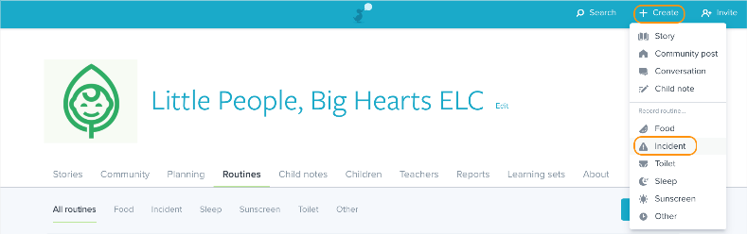
Select a child from the list and then next:
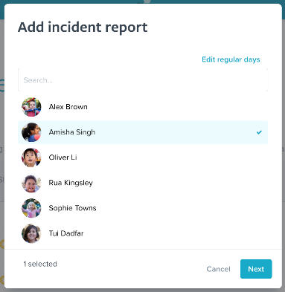
​
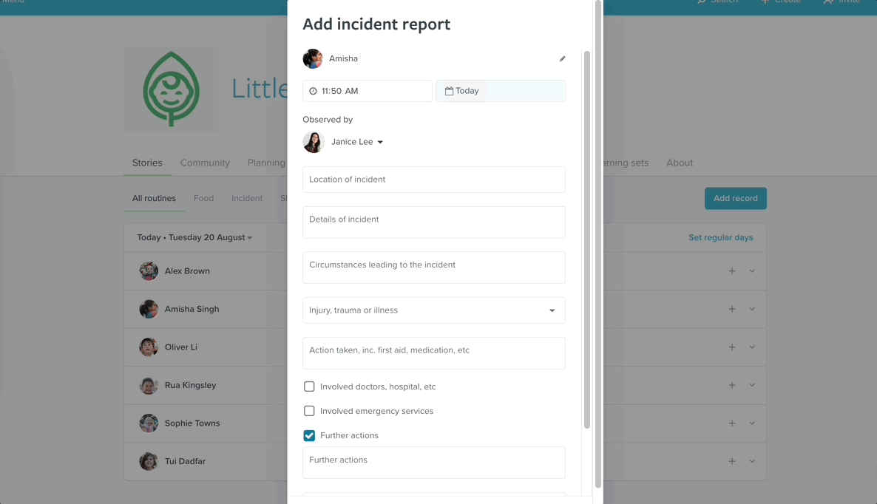
Time, day and observers
The time and day are automatically set to the present, as well as the observer set to the educator that is currently logged into Storypark. Each of these fields can be edited however. Select the time or day to change them. Select the educator's name to bring up more options:
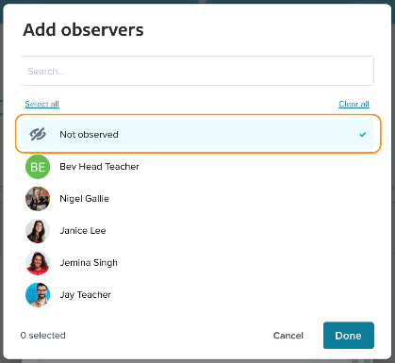

​Select one or multiple educators.
if the incident was not observed select not observed at the top of the list and then done:

Location, details and circumstances of the incident
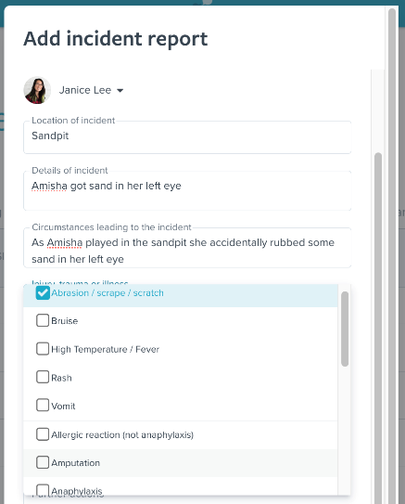
Adding the location, details and circumstances of the incident are all free text fields. Tap into each text box to start typing
Note: fields here are not mandatory, so they can be skipped if not needed. If a section of the incident report has been left empty, the headings will not be shown in the final report.
Nature of the illness/injury
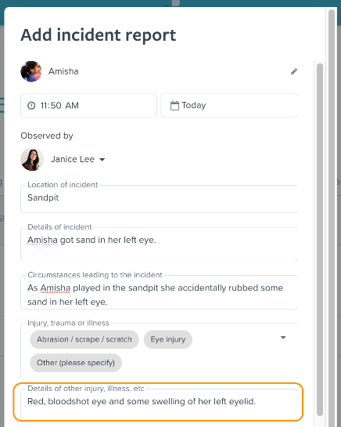
Select one or multiple, there is no limit to the number of descriptors that can be selected.
​
​If you cannot find an accurate descriptor, at the bottom of the drop-down list select Other (please specify) - this will allow you to type in the nature of the illness/injury in a field below:
​
Action taken
​
In this free text field you can include any actions taken to address the illness/injury, such as the application of first aid or medication given.
​
Below this are three optional fields involved emergency services, involved doctors/hospitals and further services. If you select the tick box next to any of these, you can then fill out further information, for example:

Notifications
​
Before sending the incident report, you may wish to detail any prior attempts to contact the child's family. Fill in the notifications free text field at the bottom of the report before sending:
If this field is left blank, the completed incident report will only display the time and date the incident report notification was sent to family admins.
​
The option to send notifications to the child's family admins on publication of the incident report will automatically be ticked.
​
This will trigger both email notifications sent to all of the child's family Admins.
Note: Family admins cannot opt out of these notifications.
​
Admin educators can however untick this to prevent notifications being sent - if for example, they've already spoken to the child's family.
​
If ticked, the published incident report will display the time and date the incident report notification was sent to family admins.
​
Publishing and approving an incident report
If the educator logging an incident report is a non-Admin on Storypark, they will first need to submit it for approval before it can be seen by the child's family.

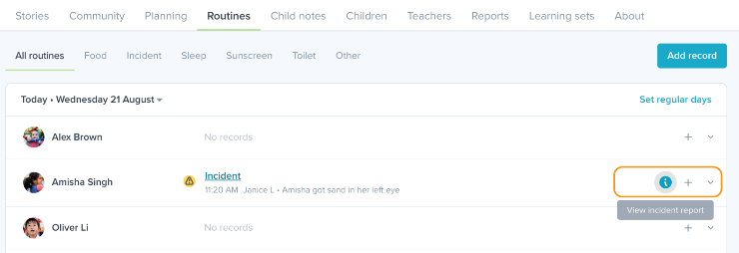
Incident reports can be viewed by educators at the service where they were created as well as the child's family Admins.
​
​From the Storypark website
​
This can be done by going to the routines on a child's profile or by going from the service's routines page and selecting the day the incident report was recorded.
​
Tap the i icon next to the incident to open up the incident report:

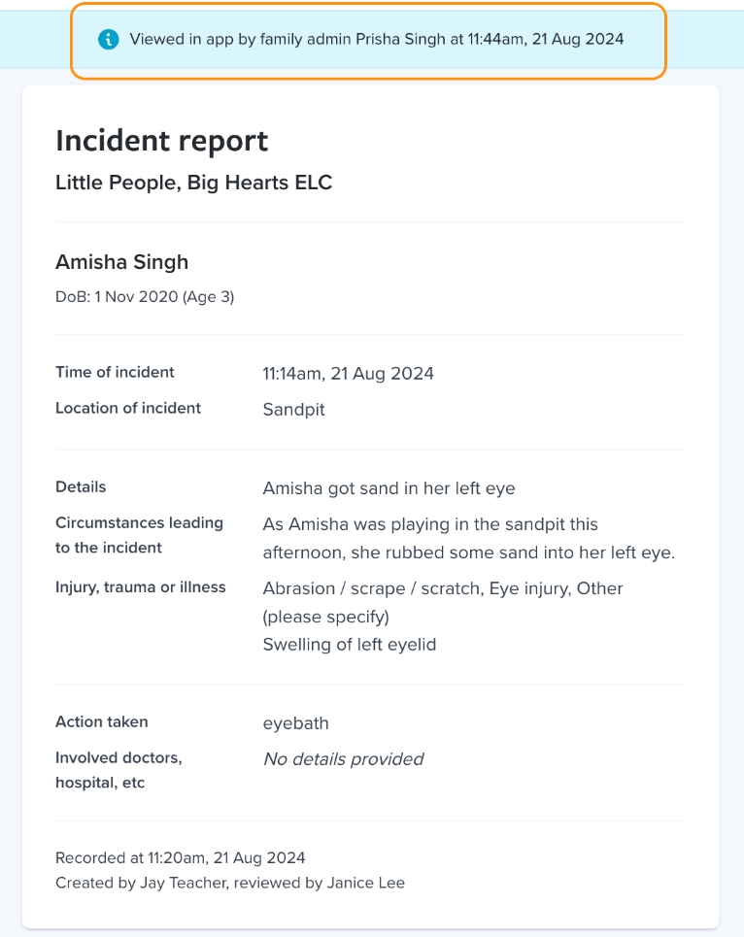
​Read receipt
When at least one of the child's family Admins has viewed the incident report, it will display a read receipt:
​This allows educators to confirm that family have received and opened the incident report - as the read receipt is only generated if at least one family Admin opens the incident report.
​
​Note: The read receipt will only detail by name the first family Admin to open the incident report. Views by subsequent family Admins will not be shown on the read receipt.
​

