Purpose
This policy will provide guidelines to ensure that the educational program (curriculum) and practice at Renown Kindergarten is:
- based on an approved learning framework
- centred on the child’s voice and agency
- promoting child’s safety
- underpinned by critical reflection and careful planning
- stimulating, engaging and enhances children’s learning and development.

Policy Statement

Values
Renown Kindergarten is committed to:
- providing an educational program that is based on reflective practice, critical analysis and planning
- supporting each child to achieve learning outcomes consistent with the national Early Years Learning Framework and/or the Victorian Early Years Learning and Development Framework (refer to Sources)
- providing an educational program where children can learn through play and are supported to make decisions, problem-solve and build relationships with others
- creating an environment that supports, reflects and promotes equitable and inclusive behaviours and practices
- involving families in the development and review of educational program and practice

Scope
This policy applies to the approved provider, persons with management or control, nominated supervisor, persons in day-to-day charge, early childhood teachers, educators, staff, students, volunteers, parents/guardians, children, and others attending the programs and activities of Renown Kindergarten, including during offsite excursions and activities.

Responsibilities | Approved provider and persons with management or control | Nominated supervisor and persons in day-to-day charge | Early childhood teacher, educators and all other staff | Parents/guardians | Contractors, volunteers and students
R indicates legislation requirement, and should not be deleted
Ensuring that the educational program is stimulating and engaging, enhances children’s learning and development, and is based on an approved learning framework (refer to Definitions) (National Law: Section 168) | R | √ | √ |  | √
Ensuring the developmental needs, interests and experiences, and the individual differences of each child are accommodated in the educational program (National Law Section 168) (refer to Inclusion and Equity Policy) | R | √ | √ |  | √
Ensuring the educational program contributes to each child:  - developing a strong sense of identity  - being connected with, and contributing to, their world  - having a strong sense of wellbeing  - being a confident and involved learner  - being an effective communicator (Regulation 73) | R | √ | √ |  | √
Designating a suitably qualified and experienced Educational Leader to direct the development and implementation of educational programs at the service (Regulation 118) | R
Ensuring the staff record includes the name of the Educational Leader at the service (Regulation 148) | R | √
Ensuring that the service’s philosophy guides educational program and practice | R | √ | √ |  | √
Ensuring that assessments of the child’s developmental needs, interests, experiences and participation in the educational program are documented (Regulation 74(1)(a)(i)) | R | √ | √ |  | √
Ensuring that assessments of the child’s progress against the outcomes of the educational program are documented (Regulation 74(1)(a)(ii)) | R | √ | √ |  | √
Ensuring that each child's learning and development is assessed as part of an ongoing cycle of planning, documentation and evaluation | R | √ | √ |  | √
Ensuring documentation of assessments includes reflection on the period of time the child is at the service, and how documented information will be used by educators at the service (Regulation 74(2)(a)(i)&(ii)) | R | √ | √ |  | √
Ensuring that there is a record of learning and development for each child, and that it is updated and maintained on an ongoing basis | R | √ | √ |  | √
Ensuring documentation is written in plain language and is easy to understand by both educators and parents/guardians (Regulation 74(2)(b)) | R | √ | √ |  | √
Ensuring a copy of the educational program is displayed at the service and accessible to parents/guardians (Regulation 75) | R | √ | √ |  | √
Ensuring that parents/guardians are provided with information about the content and implementation of the educational program, their child’s participation in the program and documentation relating to assessments or evaluations of their child (Regulation 76) | R | √ | √ |  | √
Ensuring regular communication is established between the service and parents/guardians, and they are informed about their child's learning, development and progress | R | √ | √ | √ | √
Undertaking critical reflection on children’s learning and development, both as individuals and in groups, drives program planning and implementation | R | √ | √ |  | √
Developing and evaluating the educational program in collaboration with the nominated supervisor, educators, children and families. | R | √ | √ | √ | √

Background and Legislation

Background
The Education and Care Services National Law Act 2010 (National Law) requires services to deliver an educational program (curriculum) that is based on an approved learning framework. In Victoria, approved learning frameworks for the early childhood sector are the Early Years Learning Framework (Belonging, Being & Becoming) (refer to Sources), the Victorian Early Years Learning and Development Framework (refer to Sources) and My Time Our Place, Framework for School age care in Australia (refer to Source). These documents are underpinned by practices and principles that encourage reflection and provide educators with a thorough understanding of the pedagogy of early childhood curriculum in a contemporary context.
Part 4.1 of the Education and Care Services National Regulations 2011 (National Regulations) outlines the operational requirements for educational program and practice within services, including the requirements for documentation of assessments in relation to the educational program. There is no prescribed method in the National Law or National Regulations for documenting assessment of children’s learning. Educators daily practice and curriculum decision-making should be guided by an approved learning framework. An approved learning framework provides broad direction for educators to facilitate children’s learning. Each service must determine a method that suits their individual circumstances. To meet the documentation requirements of the National Regulations, the assessment must include an analysis of children’s learning. Collecting this information enables educators to plan effectively for each child’s learning and development. It can also be used by educators to stimulate reflection on their own values, beliefs and teaching practices, and to communicate about children’s learning with children and their families.
The National Regulations require the appointment of an Educational Leader to lead the development and implementation of the educational program (or curriculum) at the service (Regulation 118). This person will have suitable qualifications and experience, as well as a thorough understanding of the Early Years Learning Framework and/or the Victorian Early Years Learning and Development Framework, enabling them to guide other educators in planning and reflection, and to mentor colleagues in implementation practices (Guide to the Education and Care Services National Law and the Education and Care Services National Regulations, p85 – refer to Sources).
The National Quality Standard is linked to the approved learning frameworks. Quality Area 1: Educational Program and Practice focuses on “enhancing children’s learning and development through the:
- pedagogical practices of educators and co-ordinators
- development of programs that promote children’s learning across five learning outcomes”
(Guide to the National Quality Standard – refer to Sources).
The educational program must also be underpinned by the service’s philosophy

Legislation and Standards
Relevant legislation and standards include but are not limited to:
- Education and Care Services National Law Act 2010
- Education and Care Services National Regulations 2011
- National Quality Standard, Quality Area 1: Educational Program and Practice
- Standard 1.1: The educational program enhances each child’s learning and development
- Standard 1.2: Educators facilitate and extend each child’s learning and development
- Standard 1.3: Educators and co-ordinators take a planned and reflective approach to implementing the program for each child
The most current amendments to listed legislation can be found at:
- Victorian Legislation – Victorian Law Today: www.legislation.vic.gov.au
- Commonwealth Legislation – Federal Register of Legislation: www.legislation.gov.au

Definitions
The terms defined in this section relate specifically to this policy. For regularly used terms e.g. Approved provider, Nominated supervisor, Notifiable complaints, Serious incidents, Duty of care, etc. refer to the Definitions file of the PolicyWorks catalogue.
Approved learning framework: A document that outlines practices that educators and co-ordinators must use to support and promote children’s learning. The Early Years Learning Framework (Belonging, Being & Becoming), the Victorian Early Years Learning and Development Framework and My Time, Our Place; Framework for School Age Care in Australia are approved learning frameworks for use in Victoria (refer to Sources).

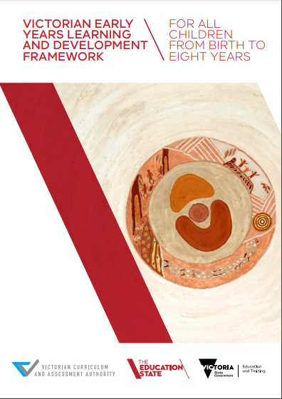 | 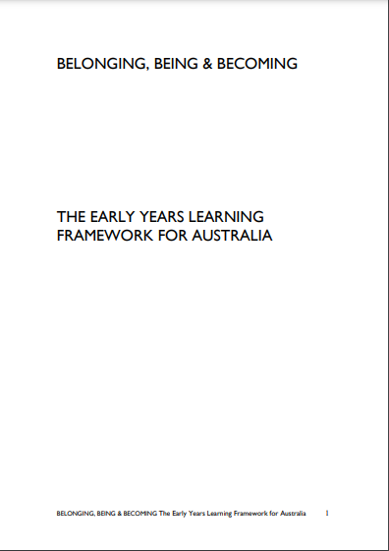 | 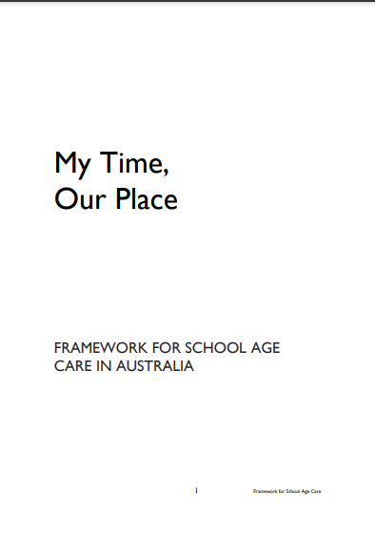
Victorian Early Years Learning and Development Framework | The Early Years Learning Framework (Belonging, Being & Becoming) | My Time, Our Place; Framework for School Age Care in Australia

Critical reflection: Reflective practices that focus on implications for equity and social justice (Early Years Learning Framework – refer to Sources).
Curriculum: All interactions, experiences, activities, routines and events, planned and unplanned, that occur in an environment designed to foster children’s learning and development (Early Years Learning Framework– refer to Sources; adapted from Te Whariki).
Each child: A phrase used in the National Quality Standard when an individualised approach is warranted, and educators are required to modify their response to meet the needs of an individual child. An example is ‘each child’s current knowledge, ideas, culture and interests provide the foundation for the program’.
Educational Leader: The approved provider of an education and care service must designate, in writing, a suitably qualified and experienced educator, co-ordinator or other individual to lead the development and implementation of educational programs at the service (Regulation 118). This person must have a thorough understanding of the Early Years Learning Framework (or other approved learning framework), be able to guide other educators in their planning and reflection, and mentor colleagues in the implementation of their practice.
Learning: A natural process of exploration that children engage in from birth, as they expand their intellectual, physical, social, emotional and creative capacities. Early learning is closely linked to early development.
Learning framework: Refer to approved learning framework above.
Learning outcome: A skill, knowledge or disposition that educators can actively promote in early childhood settings, in collaboration with children and families.
Learning relationships: Relationships that further children’s learning and development. Both adult and child have intent to learn from one another.
Play-based learning: A context for learning through which children organise and make sense of their social world as they engage actively with people, objects and representations

Sources and Related Policies

Sources
- Belonging, Being & Becoming – The Early Years Learning Framework for Australia: https://www.acecqa.gov.au/nqf/national-law-regulations/approved-learning-frameworks
- Educators’ Guide to the Early Years Learning Framework for Australia: https://www.acecqa.gov.au/resources/resource-finder
- Guide to the Education and Care Services National Law and the Education and Care Services National Regulations 2011, ACECQA: www.acecqa.gov.au
- Guide to the National Quality Standard, ACECQA: www.acecqa.gov.au
https://www.education.vic.gov.au/about/programs/Pages/marrung.aspx
- Marrung – Aboriginal Education Plan 2016 – 2026
- My Time Our Place, Framework for School age care in Australia: https://www.acecqa.gov.au/nqf/national-law-regulations/approved-learning-frameworks
- Early Childhood Australia Professional Learning Modules https://learninghub.earlychildhoodaustralia.org.au/modules/
- Victorian Early Years Learning and Development Framework – Resources for Professionals: https://www.acecqa.gov.au/nqf/national-law-regulations/approved-learning-frameworks

Related Policies
- Child Safe Environment and Wellbeing
- Code of Conduct
- Environmental Sustainability
- Inclusion and Equity
- Interactions with Children
- Nutrition, Oral Health and Active Play
- Participation of Volunteers and Students
- Road Safety and Safe Transport
- Sun Protection
- Supervision of Children
- Water Safety

Evaluation
In order to assess whether the values and purposes of the policy have been achieved, the approved provider will:
- regularly seek feedback from everyone affected by the policy regarding its effectiveness
- monitor the implementation, compliance, complaints and incidents in relation to this policy
- keep the policy up to date with current legislation, research, policy and best practice
- revise the policy and procedures as part of the service’s policy review cycle, or as required
- notifying all stakeholders affected by this policy at least 14 days before making any significant changes to this policy or its procedures unless a lesser period is necessary due to risk (Regulation 172 (2)).

Attachments
- Nil

Authorisation
This policy was adopted by the approved provider of Renown Kindergarten on 30 January 2024
REVIEW DATE: 30 January 2025

